A HIGHLY EFFICIENT AND RELIABLE INVERTER CONFIGURATION BASED CASCADED MULTILEVEL INVERTER FOR PV SYSTEMS
ABSTRACT
This paper presents an improved cascaded multilevel inverter (CMLI) based on a highly efficient and reliable configuration for the minimization of the leakage current. Apart from a reduced switch count, the proposed scheme has additional features of low switching and conduction losses. The proposed topology with the given pulse width modulation (PWM) technique reduces the highfrequency voltage transitions in the terminal and commonmode voltages. Avoiding high-frequency voltage transitions achieves the minimization of the leakage current and reduction in the size of electromagnetic interference filters. Furthermore, the extension of the proposed CMLI along with the PWM technique for 2m + 1 levels is also presented, where m represents the number of photovoltaic (PV) sources. The proposed PWM technique requires only a single carrier wave for all 2m + 1 levels of operation. The total harmonic distortion of the grid current for the proposed CMLI meets the requirements of IEEE 1547 standard. A comparison of the proposed CMLI with the existing PV multilevel inverter topologies is also presented in the paper. Complete details of the analysis of PV terminal and common-mode voltages of the proposed CMLI using switching function concept, simulations, and experimental results are presented in the paper.

BLOCK DIAGRAM FOR PROPOSED SYSTEM
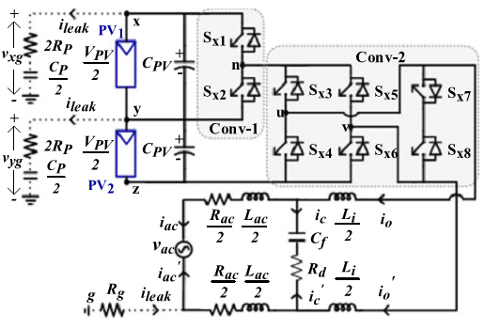
Fig. 1. Proposed five-level grid-connected CMLI with PV and parasitic elements.
DESIGNG SOFTWARE AND TOOLS:
MAT LAB /SIMULATION Software and simu power systems tools are used. Mainly control system tools, power electronics and electrical elements tools are used.

